**Storage account Events**

1. In storage account in events, create event subscription. 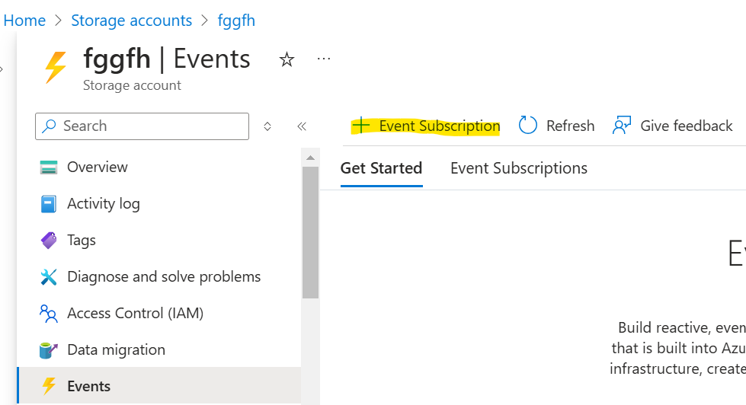
2. The event handler is required while creating the event subscription. Hence create event grid & inside that create event grid topic. 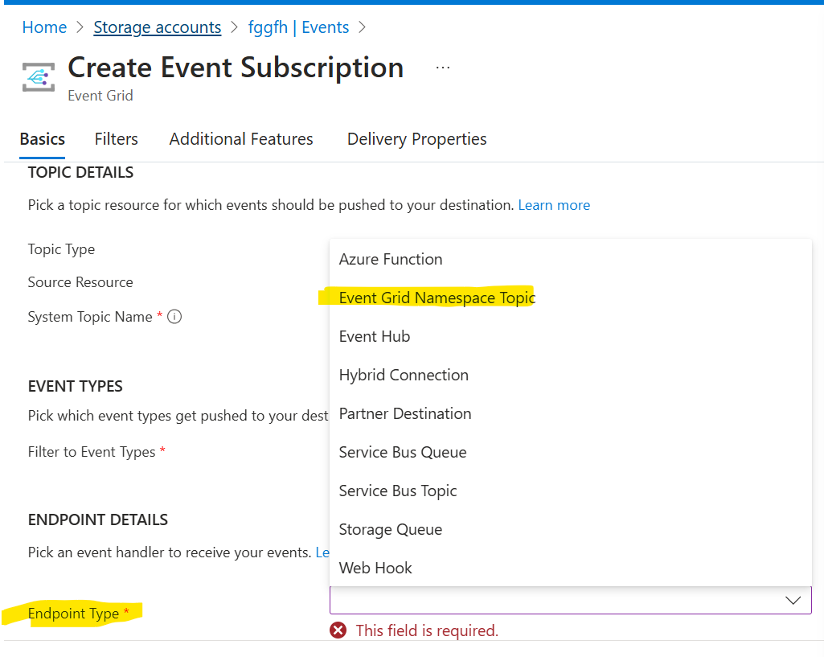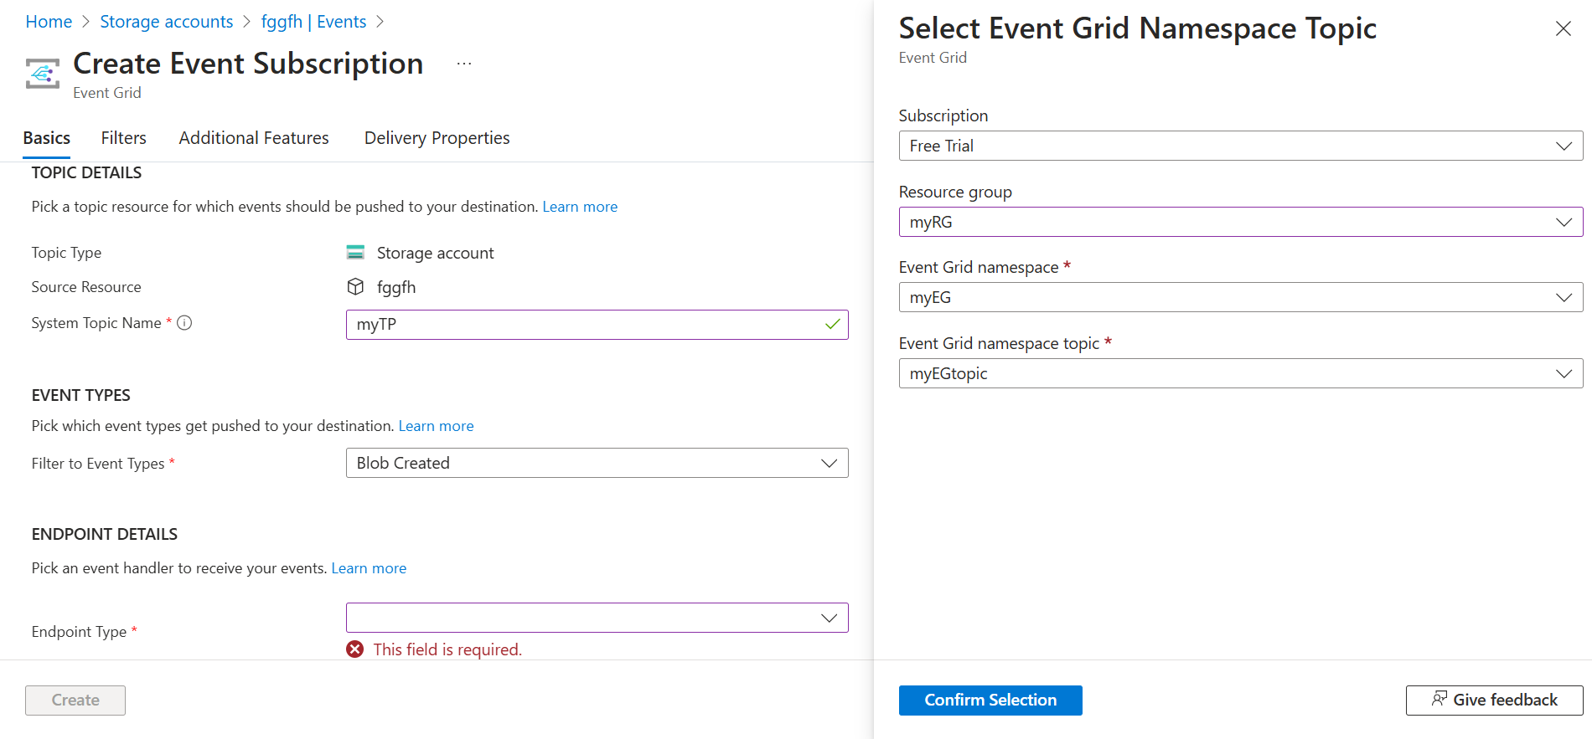
3. This would also create the topic itself its (here - myTP). Now this topic should be given Event related to access on the event grid namespace, so that the myTP can transfer the events to your event grid myEGtopic. 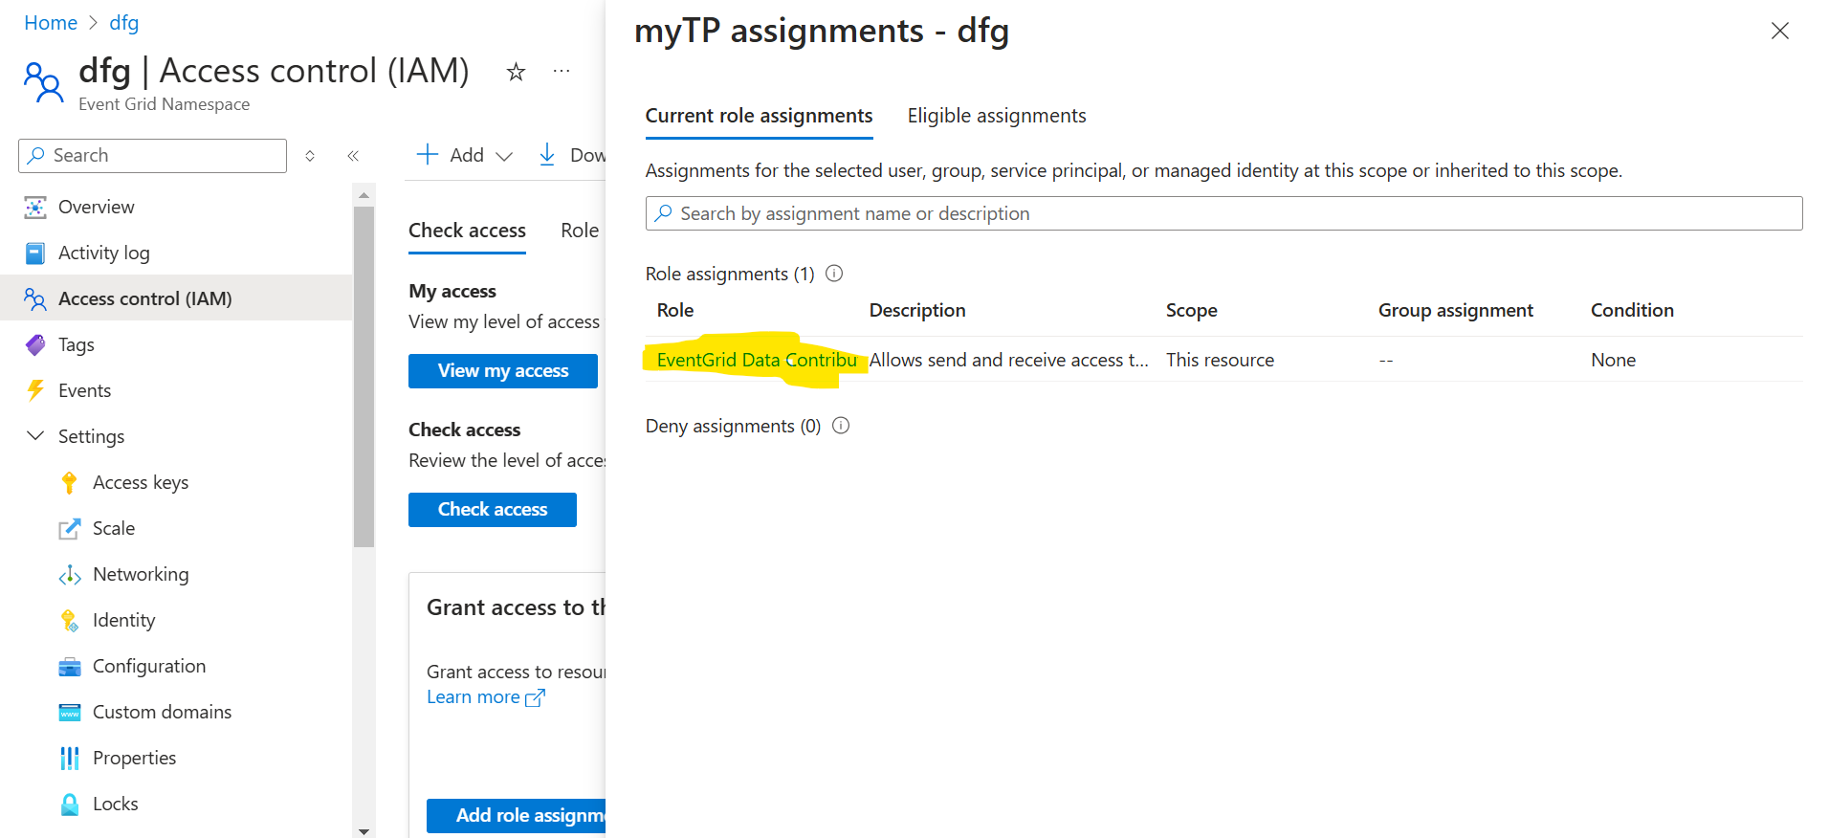
4. Now when you upload any file in the storage account you can see an event generated in the Event grid namespace. 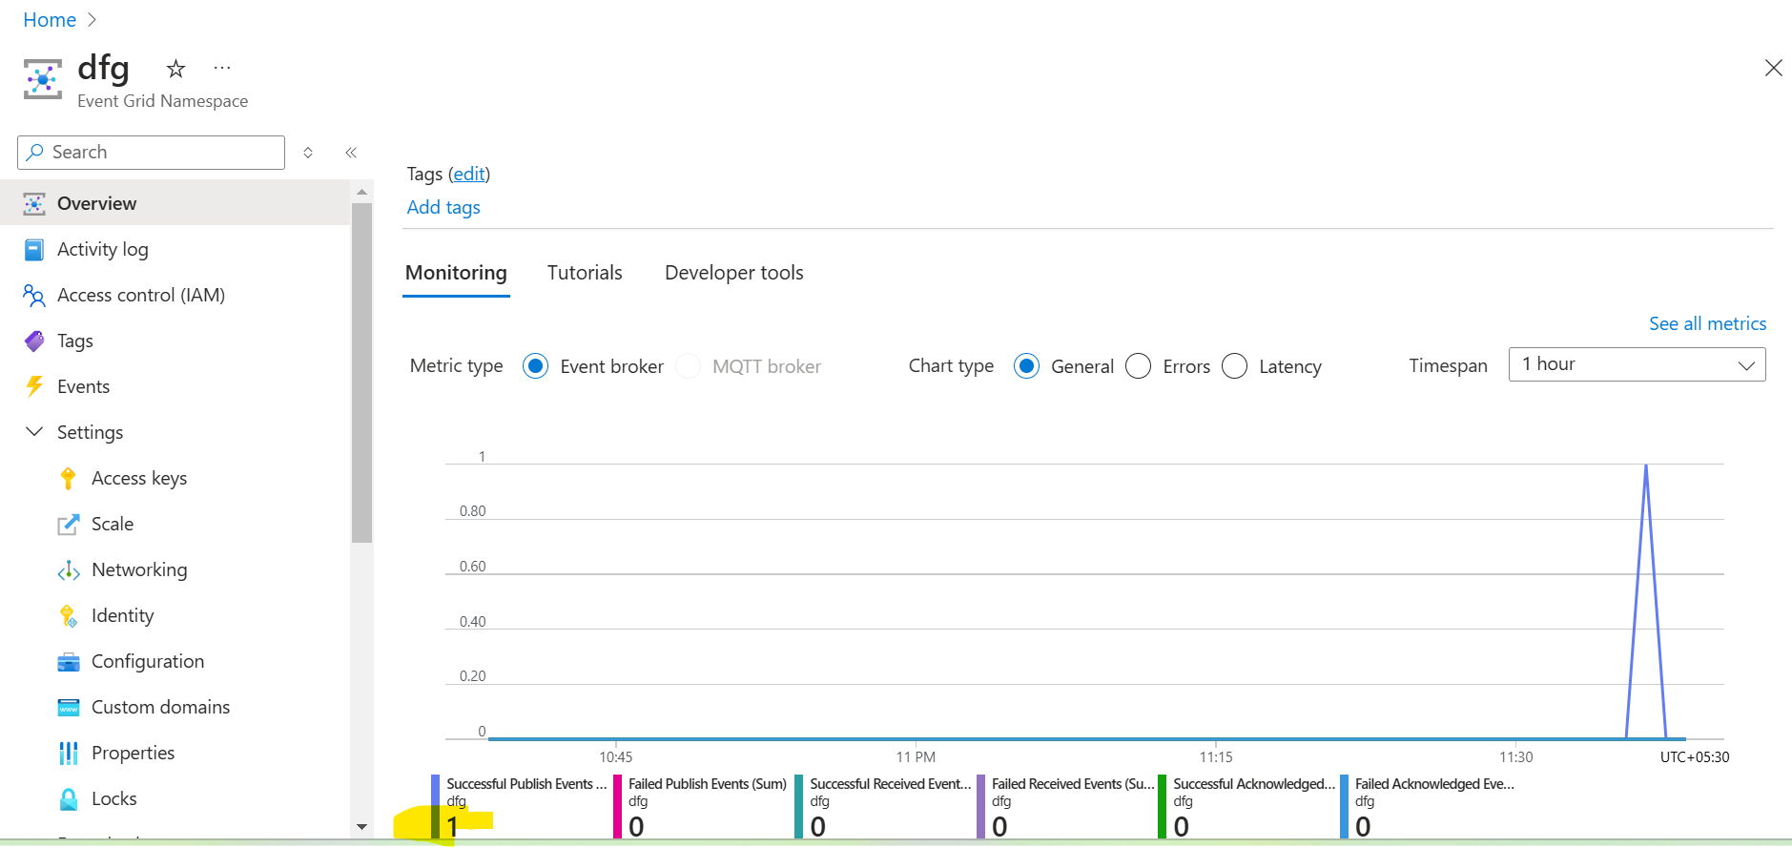
5. You can configure service bus or function app or logic app at the end of the event, not always it should be an event grid. Also on a separate note, for an event to trigger an action through logic app, you don’t need an event subscription, since there is already a task present in logic app called as event trigger in the logic app.